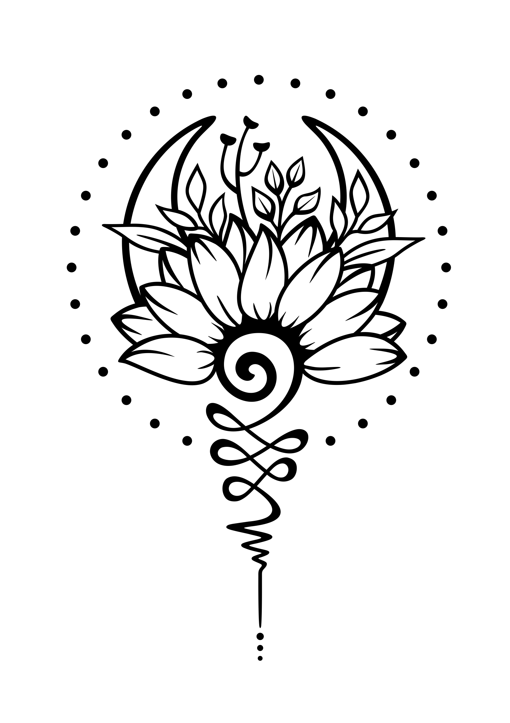

Bobbi Nodell  
206.427.4444, [gobobbi@gmail.com](mailto:gobobbi@gmail.com), bobbinodell.com

Yoga instructor with 400+ hours of training (Vinyasa, Yin, Forrest)  
Specialty: Making yoga accessible for all bodies. I like doing yoga that is a blend of styles and offers lots of modifications.

Training

2023: Forrest Yoga retreat.

2022: **HeartSaver First Aid with CPR and AED. Cascade Training Center.**

2020-2021: Forrest Yoga. 200 hours.  
This is a Hatha-inspired yoga practice created by American yogi Ana Forrest to fix what many yoga classes don’t cover – core work, intention, and healing. **Classes typically begin with deep breathing and setting an intention for the mind and an intention for the body. Studied in Indonesia in January 2020 and then online.**

**2019: Yin Yoga from Audrey Tollefsen with Junction Hot Yoga, formerly with Be Yoga Burien.**  
  
2019: Forrest Yoga workshop in Malaysia.  
  
2018: Vinyasa, 200 hours. Be Yoga Burien.

Experience

2018-current: Volunteer with Adaptive Yoga Northwest.

April 2023: Yoga instructor for the Washington State Nurses Convention in Tacoma.

2020-2024: Private instruction.